Monaghan Town
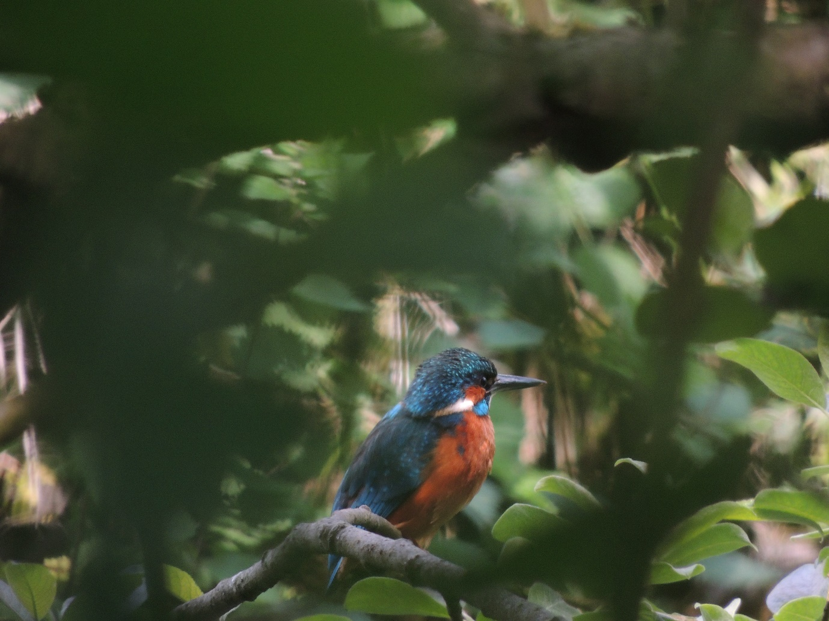Bird Survey

For: Monaghan Tidy Towns Committee
By: Joe Shannon,
Secretary Monaghan Branch
BirdWatch Ireland
Date: 19th May 2015

Table of Contents

- Introduction

- Survey Method

- Results and Analysis

- Recommendations

- Acknowledgements

- References

Introduction

This report follows on the previous Monaghan Bird Survey under taken by Stephen McAvoy in 2011/12 for Monaghan Tidy Towns Committee.

Survey Method
This survey followed the methodology used by BirdWatch Ireland for Countryside Bird Survey and used by Stephen McAvoy.
A similar route was followed whereby it commenced at Peters Lake and terminated at Milltown. The slight variation in this survey, was in following part of the newly opened Ulster Canal Walk but largely the 2012 transect route was adhered to in squares
HABGDCF+E
It should be noted that the contiguous Rossmore Park was also surveyed. The route followed the pathways to the Cootehill and Threemilehouse entrance gates. Thus three (3) ‘significant’ additional species were counted in this ‘extended’ square labelled F+: Great Spotted Woodpecker, Dipper and Little Grebe.

A total of three surveys were carried out in bright, dry and calm conditions.
19th March, 18th April and 17th May 2015.

Results and Analysis

SPECIES | SQUARE
 | A | B | C | D | E | F+ | G | H
Little Grebe |  |  |  |  |  | p
Great crested Grebe |  |  |  |  |  | p
Grey Heron |  | P |  |  |  | P
Mute Swan |  |  |  |  |  | P
Mallard |  | P |  |  |  | FL
Buzzard | P |  |  |  |  | P |  | P
Sparrowhawk |  |  |  |  |  | P
Water Rail |  |  |  |  |  | p
Moorhen | P | P |  | P |  | P
Coot |  |  |  | P |  | P
Black headed Gull |  |  |  | P
Feral Pigeon | P |  |  | P
Wood Pigeon | P | P | P | P | P | P | P | P
Collard Dove | P | P |  | P | P |  |  | P
Common Swift |  |  | P | P
Kingfisher |  | P
Great Spotted Woodpecker |  |  |  |  |  | P
Sand Martin |  |  |  |  |  | p
Swallow | P | P |  | P | P | P | P | P
House Martin |  |  |  |  |  | P
Pied Wagtail | P |  |  |  | P |  | P
Grey Wagtail |  | P | P |  |  | P
Dipper |  |  |  |  |  | P
Wren | p | p | p | p | p | p | p | p
Dunnock | p | p |  |  | p | p |  | p
Robin | p | p | p | p | p | p | p | p
Song Thrush | p |  | p |  | p | p
Mistle Thrush | p | p |  |  |  | p | p | p
Redwing |  | p
Fieldfare |  | p
Blackbird | p | p | p | p | p | p | p | p
Blackcap | p | p | p | p |  | p | p | p
Sedge Warbler |  |  |  |  |  |  | p
Willow Warbler |  | p | p | p | p | p | p | p
Chiffchaff |  | p | p | p | p | p | p | p
Goldcrest |  | p |  | p | p | p |  | p
Spotted Flycatcher |  | p |  |  |  | p
Great Tit | p | p |  | p | p | p | p | p
Coal Tit |  | p | p |  | p | p | p
Blue Tit | p | p |  | p |  | p | p | p
Long-tailed Tit |  | p |  |  |  | p | p
Treecreeper |  | p |  |  |  | p
Magpie | p | p | p | p |  | p | p
Jay |  |  |  |  |  | p
Jackdaw | p | p | p | p | p | p | p | p
Rook |  | p | p | p | p | p | p | p
Hooded Crow |  |  | p | p |  | p |  | p
Raven |  | p |  |  |  | p
Starling | p | p | p | p | p | p | p | p
House Sparrow | p | p | p | p | p |  | p
Chaffinch | p | p | p | p | p | p | p | p
Redpoll |  | p |  |  |  | p
Goldfinch |  | p | p | p |  | p | p | p
Greenfinch | p | p |  | p | p | p | p
Siskin |  |  |  |  |  | p
Bullfinch |  | p | p |  | p | p | p
Common Crossbill |  |  |  |  |  | p
Reed Bunting |  |  |  |  |  | p

Total Species 58. This number is quite exceptional for a largely urban environment but the excellent habitats of the Ulster Canal (walkway) and Rossmore Forest Park, in part, account for the high number of species. The following species of note were recorded.
Kingfisher (breeding)
Grey Wagtail (breeding)
Dipper (breeding)
Great Spotted Woodpecker (breeding and recently recolonizing Ireland)
Little Grebe (breeding)
Spotted Flycatcher (breeding)

Wintering: Black-headed Gull
Fieldfare
Redwing
Great crested Grebe

Species overview has been comprehensively covered in Stephen McAvoy’s report of 2011/12.

Table: Number of Species recorded in each square.

Square
 | A | B | C | D | E | F+ | G | H
Species | 22 | 35 | 20 | 26 | 21 | 48 | 24 | 21
Percentage of total | 39% | 61% | 35% | 46% | 37% | 84% | 42% | 37%

The results are broadly similar with the 2012 survey. As expected the highest percentage of species were in squares B and F+.

Comments:
Though the Ulster Canal Walkway is thankfully proving very popular with walkers/cyclists, the design and construction has had no apparent negative impact and, in fact, with the regeneration of riparian shrubs and plants the ideal conditions exist for further enhancement of this site.

Acknowledgements
Again thanks to Emer and the Tidy Town Committee for continuing with these bird surveys.

References.
David Balmer et al (2013) Bird Atlas 2007 – 11, The Breeding and wintering Birds of Britain and Ireland.
Killian Mullarney et al (2001) The Collins Bird Guide, HarperCollins, London.

