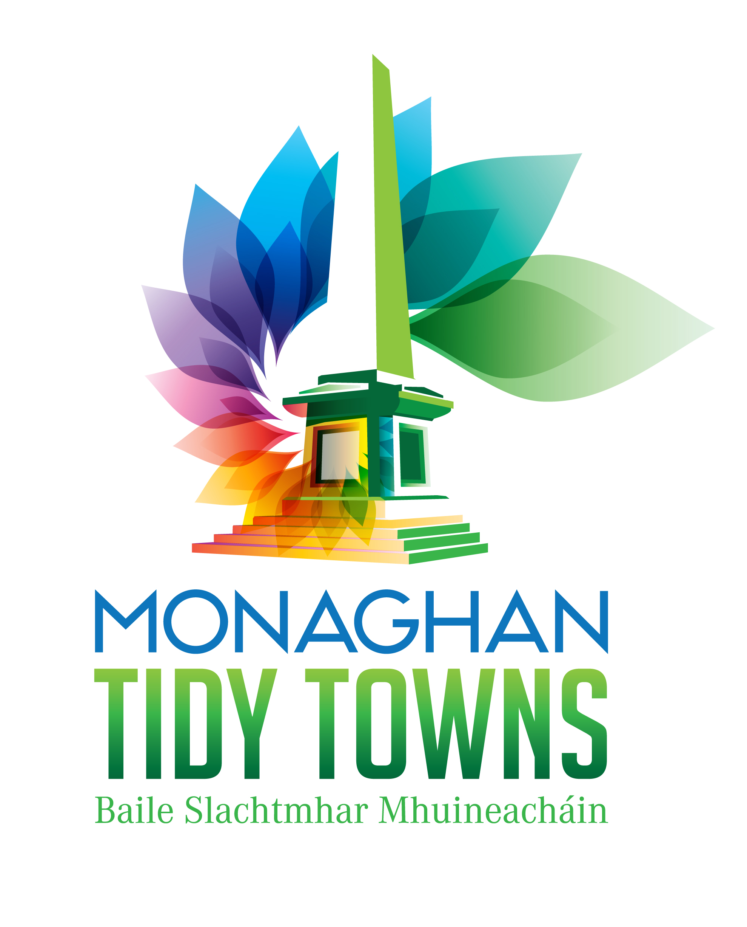

Monaghan Town Biodiversity Plan (Updated 2015)

Bodies to be consulted with regard to developing and planning habitat management for Monaghan ie Local Biodiversity Plan:
Monaghan Tidy Towns, Monaghan Town Council, Monaghan County Council, Heritage Council. the general public….

The purpose of this Local Biodiversity Plan is to provide a template for planning and executing biodiversity actions, projects and any other works in the Monaghan Town area.

Monaghan Tidy Towns Committee commissioned Flynn Furney Environmental Consultants to do a habitat survey of Monaghan Town and its environs in 2010. The resulting survey was presented to the committee in late 2010 and to a public meeting in February 2011.

We have used the survey as a basis for a biodiversity plan for the town. The first plan (2012) formed the basis of consultations with the local authorities and with other stakeholders and the public. This plan has been updated regularly to take into account developments such as the Greenway currently under construction. .

The habitat survey has shown that there is a relatively broad range of habitat types within the area under survey.

Included among these is only one site which has been designated for the protection of habitat that is considered to be of national importance (proposed Natural Heritage Area). While other areas contain a relatively diverse range of plants, they are not so noteworthy and would not be statutorily protected (e.g. road verges, old walls). However, it is reasonable to describe these of being of local significance. That is, their loss would be significant to native species in a local context. They are therefore worthwhile protecting and even enhancing in the medium to long-term.

Local Biodiversity Areas are non-statutorily designated areas which are
considered to be of local ecological significance. They have been in use in
Ireland since 2005. The term does not confer any legal protection or restriction
on the site but does serve to highlight areas of particular biodiversity importance
to a community or area (see Mabey, 1980).
It is proposed that the following areas be adopted as Local Biodiversity Areas:

Proposed Local Biodiversity Areas

Area | Rationale
Ulster Canal Park (+Greenway)  Peter’s Lake  St. Davnet’s /Rooskey  Glen Road  Convent Lake  Tom Young’s Wood  Rossmore Park  The Shambles River  The Ulster Canal (+ Greenway)  River Blackwater  Wright’s Wood | Linear habitat, central location  Diverse wetland habitat in central location  Variety of habitat and tree species  Example of semi-natural woodland  Value for wildfowl, undisturbed reed fringe habitat  Diverse broadleaved woodland, rare species  Variety of habitats, extent and accessibility  Linear habitat, urban river  Linear wetland habitat, protected species  Linear habitat, salmonid stream  Diverse broadleaved woodland, pNHA

Recommendations for Habitat and Species Management
The following section makes recommendations for habitats included in this
survey.

Location |  | Actions | Actioned
Ulster Canal Park | Year 1  Year 1 - 3 | The un-mown area of amenity grassland here should be widened.  The infestation of Japanese knotweed at the north of the site should be removed | √  √
Peter’s Lake | Ongoing  Year 1 | Lakeside trees should be maintained  The infestation of Japanese knotweed should be removed  This site should be considered for activities such as school visits  Resources for schools (worksheets) to be completed to match trail | √  Ongoing  √
St. Davnet’s | Done | The ground managers should be contacted with regard to carrying  out removal of the Japanese knotweed here. | done
Glen Road | Ongoing  Year 1 -3 | Some litter may be removed from the site  Householders could be contacted re: correct disposal of garden  waste – Local survey proposed | √  √
Convent Lake | Year 2 | . Removal of the infestation of Japanese knotweed should be carefully planned and carried out here as there is a risk of spreading to the  remainder of this site. | Ongoing
Tommy Young’s Wood | Year 2/3  Site selected for biodiversity project  Year 1 (August) & 2 | Some sycamore should be removed from the site  Some non-intrusive signage within the woodland may be  considered  A number of educational uses of the site should be considered – outdoor classroom  Insect Hotel to be added  Fencing to be repaired | Ongoing  done  done  done  done
Rossmore Park | Year 1  Year 1 and ongoing | Some sycamore should be removed from the site. Coillte may be contacted in this regard.  An anti-litter project or clean-up may be planned | Done  Regular
The Shambles River | Ongoing | River should be kept clear of debris and rubbish | ongoing
The Ulster Canal | Council has set aside funding for this area | Some litter and rubbish should be removed from the canal | ongoing
River Blackwater | Year 1 / 2 | The river should be signed at the larger bridges  Debris should be removed from the river | to be actioned  ongoing
Wright’s Wood | Liaison with owner to be arranged | Fencing should be improved to stock-proof the woodland areas. | to be actioned

Biodiversity Projects for Monaghan Town

The habitat survey has indicated some areas of possible work to conserve enhance and celebrate the biodiversity of the town. Recommendations for possible biodiversity-based projects for Monaghan suggested are:

Tom Young’s Wood should be used for activities for environmental
education or biodiversity awareness. It is recommended that some
interpretation be put in place to inform townspeople of the value of this
area. This may be based in the town or in the wood itself.

Action - TY Wood selected for biodiversity project , we worked with Action for Biodiversity Officer to develop outdoor classroom, trail, resources for schools, web site etc Greenway now proceeds through this area making it more accessible. Interpretive signs and educational worksheets developed.

Similarly, some interpretation for the Ulster Canal should be devised. The
Park here would be highly suitable for biodiversity awareness events.
Some longer canal walks are also recommended.
In contact with the council regarding upkeep of this area. Clean up of area around canal has funding allocated to it. We have lobbied for the canal walk area to be opened up more to public view to discourage anti-social behaviour there.
Update 2015 – Sign needs to be replaced /repaired

A kingfisher survey of the River Blackwater would be a highly useful
project that could easily be achieved by a community group.
Kingfishers spotted by local Birdwatch Ireland expert along canal. Locations not published for protection reasons
Complete update of Bird Survey completed May 2015

A Monaghan wildlife ‘trail’ could be created, choosing some of the sites
highlighted in this present report. A single wildlife information sign could
be created and some literature produced for a self-guided trail.
Wildlife sign sited at Peters Lake. Posts along route to be simple but carry QR codes to link to more information on web site. This project complete.
A further trail now added along the Ulster Canal Greenway with 5 signs and activity sheets. Another two signs now being added at the Lock House on hedgerows and bats/nightlife.

Wright’s Wood represents an excellent venue for wildflower or fungi walks.
However, access not currently allowed to the site, which is in private
ownership. It is recommended that the owner be contacted if the group
are interested in using this site.
Other projects above taking priority over this one but will be revisited

A web site could be developed to record the biodiversity of Monaghan Town with information linked to the proposed biodiversity interpretive signage for the town.
Web site constructed with pages linking to QR codes on wildlife trail. Web site carries copies of reports, plans etc.

A podcast accessible from this site could also be developed.
Being developed in association with site

A resource pack for schools could be developed, linked with the web site with sample lesson plans for teachers and activities for pupils.
Continually being developed in association with web site.
Biodiversity “Toolkit” sourced and developed by TidyTowns network available to schools from the library.
Identification keys for butterflies and bumblebees also made available.

The Monaghan Tidy Towns Insect Hotel for Schools project could be linked to the biodiversity web site.
Building of Insect Hotels has expanded to local community groups and estates

A dragonfly and damselfly survey would also be a very useful and
achievable piece of work. There are numerous sites where this could be
carried out including the canal, the two rivers and Peter’s and Convent
Lake.
Surveys: Birds, Trees, Habitats Butterflies will be supplemented by surveys on dragonflies, butterflies.
Links will also be provided to the Notice Nature and other related sites when ready.

New Tidy Towns logo reflecting biodiversity theme
Completed

Biodiversity area within allotments site at Killygoan including interpretive signs and information
Completed

Biodiversity workshops for Junior Tidy Towns members to be continued
Ongoing. Eco camps take place every summer.

Web site – www.monaghantownbiodiversity.com
Ongoing
Biodiversity trail now being put in place along Greenway project (cycle/walking trail currently being constructed along the Ulster Canal route from the Clones Road through the town as far as the Education Campus on the N12)
May 2014 and development continuing
Biodiversity inspired logo for the Greenway
Completed – dragonfly is part of logo
Education materials to schools – biodiversity kit for primary schools made available from the library
Completed
Biodiversity resources made available to schools – butterfly key, bumblebee key, etc
Completed

Bulb planting project over two years (crocus, daffodil, tulip) with the help of the Irish Wildlife Trust
Year 1 complete – 15000 bulbs planted (2013)
Year 2 complete – 5000 bulbs planted (2014)
Year 3 – plans to plant 10,000 further bulbs (tulips and alium) (2015)

A school’s “Design a Bird Feeder” (from recycled materials) competition to be displayed the top ten in an empty shop window.
Completed – display in shop window in lower Dublin Street.

Organise a bat detection training night and a night for training for people to participate in the All Ireland Daubenton's Bat Waterway Survey to get people surveying their local river/canal.
Organised and completed 2014
School Pollinators – supply of seeds to participating schools - underway
Lichens survey – underway
Urban Orchard – liaison with St Davnet’s Hospital on the existing urban orchard which is five minutes from the town centre – Underway but extended to Dispersed Urban Orchard – over 100 trees given to community to plant in gardens around the town, spring 2015. Good spread achieved with both apple and pear trees. Mapped. Project to be extended with other fruit trees and bushes for 2016.
Develop a Community Pollinators Project – supplying young fruit trees, seeds and perennials to the community – we are collecting the contacts and particularly the addresses of those participating so we can map the development of our dispersed “Urban Orchard” throughout the town – underway – see above

Marketing and promoting Monaghan as a BIODIVERSITY TOWN
Full page of articles in the Northern Standard for Biodiversity Week 2015 – done
Northern Sound Radio – interviews etc – done
Walks and Talks – Wild on the Greenway April 2015, Monaghan is Wild May 2015, Birds by Bike June 2015
Biodiversity Town banner (x2) done – for display at appropriate places in town.
Use of (empty) sign boxes at cinema for biodiversity info – summer 2015

